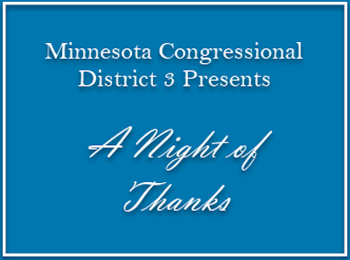
2019 Jackie Stevenson Awards
Nominations Form

Have someone you think represents the idea of our award namesakes? Please take a moment and complete the form below. Mail it and any additional information to:

Cheryl Poling, 18980 Pheasant Circle, Eden Prairie, MN 55346

The committee will review this nomination form as provided. No additional research will be done.

Nominations must be received by end of day October 18, 2019.

Nominee Name (Required):

Nominee’s Email (Required):

Nominee’s Phone Number (Required):

I am nominating this person for (Choose One):

Jackie Stevenson Award — for a consummate volunteer.

Rick Nelson Award — for someone who “makes the trains run on time.”

Sen. Linda Scheid Award — for a local legislator who works hard for everyone

Newcomer of the Year Award — for a volunteer new to the party (from early 2015 through today) who worked hard to elect Democrats in CD3

I am nominating this person because (Required—document will expand to extra pages):

Nominator (Your) Name (Required):

Nominator (Your) Email (Required):

Nominator (Your) Phone Number (Required):

Who joins you in nominating this person? (Optional)

